Command: PLINE

Specify start point: 0,36

Current line-width is 0.0000

Specify next point or [Arc/Halfwidth/Length/Undo/Width]: 2,36

Specify next point or [Arc/Close/Halfwidth/Length/Undo/Width]: 3,35

Specify next point or [Arc/Close/Halfwidth/Length/Undo/Width]: 8,35

Specify next point or [Arc/Close/Halfwidth/Length/Undo/Width]: 8,60

Specify next point or [Arc/Close/Halfwidth/Length/Undo/Width]: 23,60

Specify next point or [Arc/Close/Halfwidth/Length/Undo/Width]: 23,35

Specify next point or [Arc/Close/Halfwidth/Length/Undo/Width]: 38,35

Specify next point or [Arc/Close/Halfwidth/Length/Undo/Width]: 38,0

Specify next point or [Arc/Close/Halfwidth/Length/Undo/Width]: 28,0

Specify next point or [Arc/Close/Halfwidth/Length/Undo/Width]: 28,25

Specify next point or [Arc/Close/Halfwidth/Length/Undo/Width]: 15,25

Specify next point or [Arc/Close/Halfwidth/Length/Undo/Width]: 15,30

Specify next point or [Arc/Close/Halfwidth/Length/Undo/Width]: 1,30

Specify next point or [Arc/Close/Halfwidth/Length/Undo/Width]: 0,31

Specify next point or [Arc/Close/Halfwidth/Length/Undo/Width]: 0,36

Specify next point or [Arc/Close/Halfwidth/Length/Undo/Width]:

Command: REGION

Select objects: 1 found

Select objects:

1 loop extracted.

1 Region created.

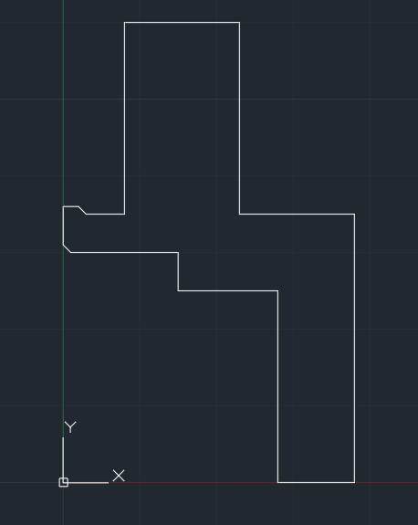

Command: REVOLVE

Current wire frame density: ISOLINES=4, Closed profiles creation mode = Solid

Select objects to revolve or [MOde]: 1 found

Select objects to revolve or [MOde]:

Specify axis start point or define axis by [Object/X/Y/Z] <Object>: X

Specify angle of revolution or [STart angle/Reverse/EXpression] <360>:

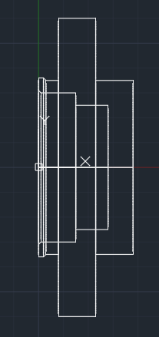

Command: FILLET

Current settings: Mode = TRIM, Radius = 0.0000

Select first object or [Undo/Polyline/Radius/Trim/Multiple]:

Enter fillet radius or [Expression]: 10

Select an edge or [Chain/Loop/Radius]:

1 edge(s) selected for fillet.

Command: FILLET

Current settings: Mode = TRIM, Radius = 10.0000

Select first object or [Undo/Polyline/Radius/Trim/Multiple]: Regenerating model.

Resuming FILLET command.

Select first object or [Undo/Polyline/Radius/Trim/Multiple]:

Enter fillet radius or [Expression] <10.0000>: 1

Select an edge or [Chain/Loop/Radius]:

1 edge(s) selected for fillet.

Command: FILLET

Current settings: Mode = TRIM, Radius = 1.0000

Select first object or [Undo/Polyline/Radius/Trim/Multiple]:

Enter fillet radius or [Expression] <1.0000>: 0.5

Select an edge or [Chain/Loop/Radius]:

1 edge(s) selected for fillet.

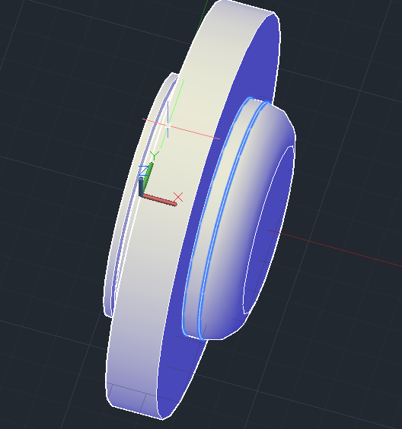

Command: ROTATE3D

Current positive angle: ANGDIR=counterclockwise ANGBASE=0

Select objects: 1 found

Select objects:

Specify first point on axis or define axis by

[Object/Last/View/Xaxis/Yaxis/Zaxis/2points]: Y

Specify a point on the Y axis <0,0,0>:

Specify rotation angle or [Reference]: 90

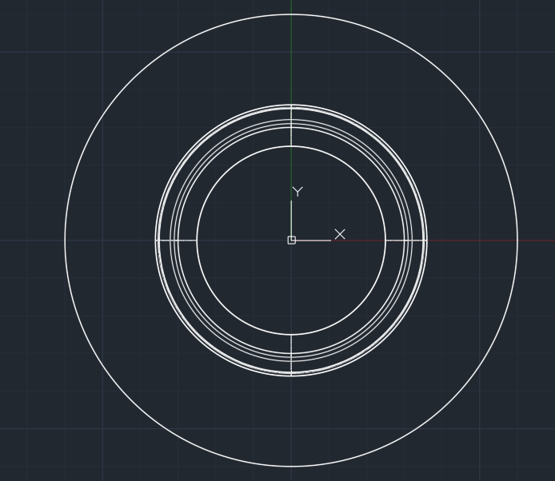

Command: CYLINDER

Specify center point of base or [3P/2P/Ttr/Elliptical]: 0,-47.5

Specify base radius or [Diameter]: D

Specify diameter: 11

Specify height or [2Point/Axis endpoint]: -13

Command: CYLINDER

Specify center point of base or [3P/2P/Ttr/Elliptical]: 0,-47.5,-13

Specify base radius or [Diameter] <5.5000>: D

Specify diameter <11.0000>: 17

Specify height or [2Point/Axis endpoint] <-13.0000>: -10

Command: UNION

Select objects: 1 found

Select objects: 1 found, 2 total

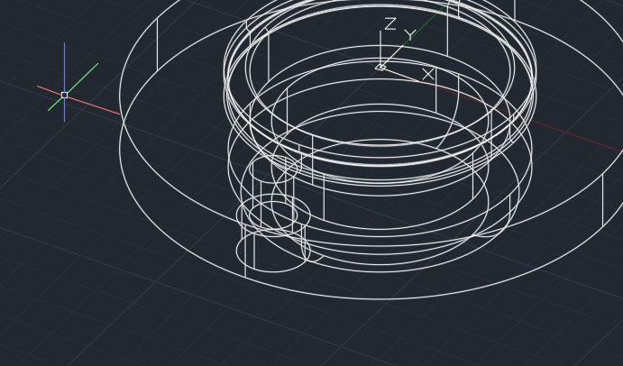

Command: ARRAY

1 found

Enter array type [Rectangular/PAth/POlar] <Polar>: PO

Type = Polar Associative = Yes

Specify center point of array or [Base point/Axis of rotation]:

Select grip to edit array or [ASsociative/Base point/Items/Angle between/Fill angle/ROWs/Levels/ROTate items/eXit]<eXit>:

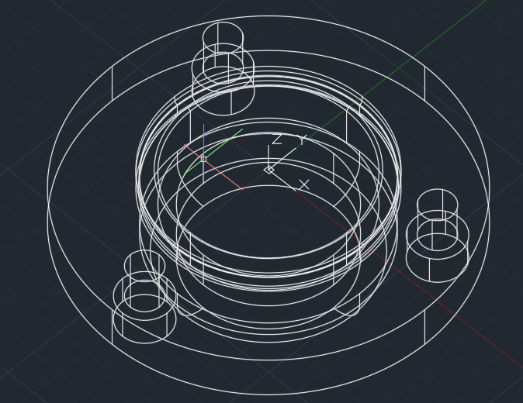

Command: EXPLODE

Select objects: 1 found

Select objects:

Command: SUBTRACT

Select solids, surfaces, and regions to subtract from ..

Select objects: 1 found

Select objects:

Select solids, surfaces, and regions to subtract ..

Select objects: 1 found

Select objects: 1 found, 2 total

Select objects: 1 found, 3 total

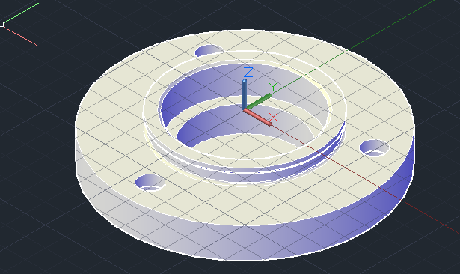

Command: PLINE

Specify start point: 100,40

Current line-width is 0.0000

Specify next point or [Arc/Halfwidth/Length/Undo/Width]: 100,70

Specify next point or [Arc/Close/Halfwidth/Length/Undo/Width]: -100,70

Specify next point or [Arc/Close/Halfwidth/Length/Undo/Width]: -100,40

Specify next point or [Arc/Close/Halfwidth/Length/Undo/Width]: 100,40

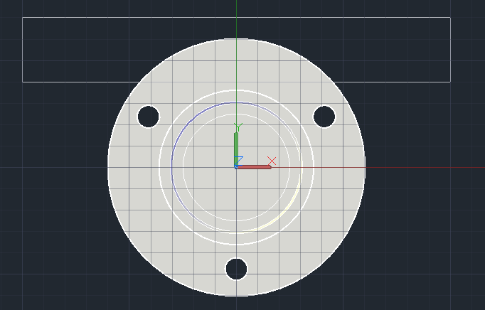

Command: EXTRUDE

Current wire frame density: ISOLINES=4, Closed profiles creation mode = Solid

Select objects to extrude or [MOde]: 1 found

Select objects to extrude or [MOde]:

Specify height of extrusion or [Direction/Path/Taper angle/Expression] <-10.0000>: -38

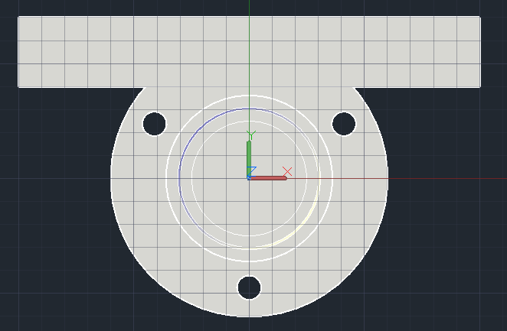

Command: SUBTRACT

Select solids, surfaces, and regions to subtract from ..

Select objects: 1 found

Select objects:

Select solids, surfaces, and regions to subtract ..

Select objects: 1 found

Select objects:



